Machine Vision Lab (Room E-2)
Topics Covered:
Image Generation & Acquisition
Histograming & Thresholding
Edge Detection
Pattern Matching
Particle Analysis
Script Builder
Gray Scale

Equipment Required:
Machine Vision Acquisition Board (E-2)
LabVIEW 7.0 or better with NI-IMAQ
Video Camera & Lighting

INDUSTRIAL MACHINE VISION
Machine vision is the Practical Application of Image Processing and Computer Vision Technologies to Address the Needs of Real-World Manufacturing and Process Environments. It is normally distinguished from computer vision or image processing by Three additional requirements:
- Real-Time Imaging & Processing of Real Scenes
- Extraction of Significant Information or Data Through Image Understanding
- Use of that Understanding to Control Consequential Action
Machine Vision is employed for a number of functions including:
- Object Recognition
- Product Inspection
- Robot Guidance
- Piece Part Inspection
- Flaw or Fault Detection
- Contamination Detection
- Flow Analysis

Other image oriented functions utilize many of the same tools as Machine Vision but are grouped separately because they lack the “real-time” and “control” aspects of Machine Vision applications. Examples include:
- Video Enhancement
- Picture Restoration
- f/x
- Graphics Generation
- Satellite Photo Enhancement
- Medical Imaging Analysis
- Geo-Survey Analysis

Examples of Machine Vision Based Control Applications include:
- Industrial
- Identification or Recognition - Sorting & Packaging (Postal Sorting – Lockheed)
- Machine Guidance - Recognition, Targeting, Alignment (Robot Alignment – Universal)
- Inspection or Measurement - Defects, Metrology, or Quality (Pill Counting – Innovation Ass.)
- Vehicle Guidance
- Cars & Trucks - Road Tracking, Obstructions, Collision Avoidance
- Smart Bombs - Targeting, Tracking
- Traffic Control Tolls, ID Licenses, & Safety
- Medical Treatment Protocols
- Security Motion Classification, Individual Identification, Threat Assessment
In these applications the ultimate objective is to Drive Decisions and Take Action.
Machine Vision is utilized in Industrial applications for the same general reasons as most other machine-based automation tools: Tireless consistency, precision, speed, low recurring cost per unit of production, .… It suffers from many of the same draw backs: High capital commitment, extended start-up lead time, maintenance, problematic exception handling, limited adaptability, ….

The Machine Vision Process
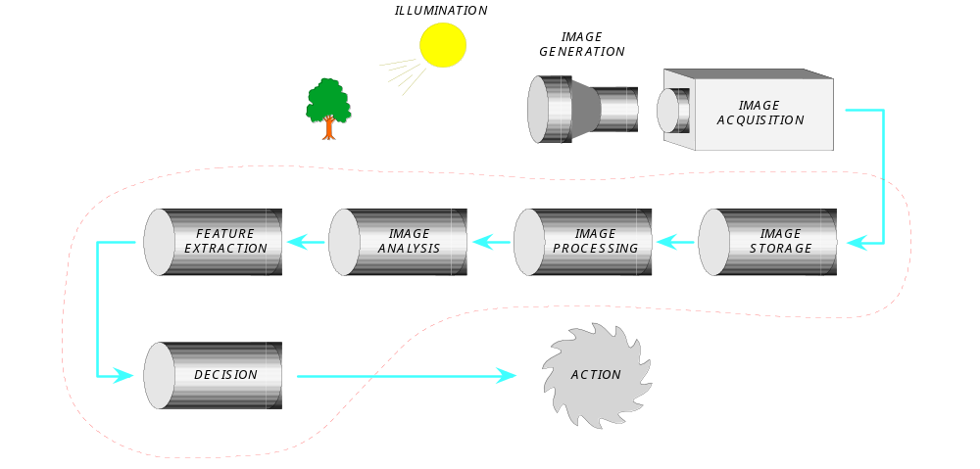

The process embraces several technological domains including electro-optics, optics, digital cameras, computer architecture and hardware, and transducers. Any of the steps in the process may be highly customized to meet the requirements of the specific application so a thorough systems engineering analysis of the problem definition and objectives is desirable. The elements of the process within the dotted red line are typically conducted within a computer or microprocessor.
Image Generation & Acquisition
Acquiring a useful, understandable image is one of the most important aspects of Machine Vision problems. The type of Image can vary depending on the application. Common alternatives include:
- Grayscale - intensity
- Color - intensity and wavelength ( almost 4D data in a sense, really 3 conjoined 3D data sets)
- Alternate spectra - infrared, x-ray or other spectral regions
- 3D - Range data or perspective
- Combinations of the above

The particulars for each of these are beyond the scope of this exercise but two common elements are worth noting:
- All generate a (usually large) highly-ordered data structure. The array of data correspond to an array of picture elements (pixels) representing the original image or scene. These pixels have a rigid “spacial” relationship to one another that is critical for the assumptions required by the computer algorithms use to analyze these data.
- Any enhancement of features of interest or suppression of background and noise is best done in the image generation (optical) phase since such processes can be thought of as occurring at the speed-of-light. Once the image is acquired then enhancement or noise reduction can be accomplished only as fast as hardware and software can operate.
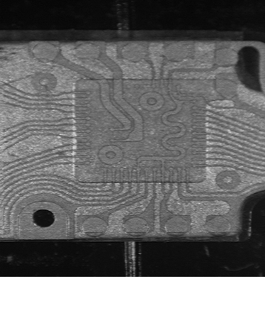An Example of Illumination Domain Problem Solving
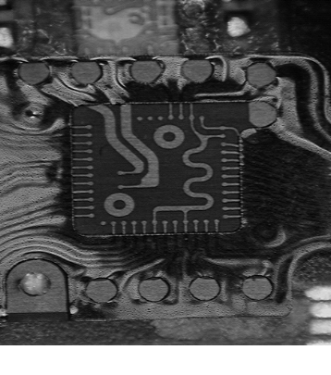

Spectral Filtered, Cross Polarized Illumination
Cameras are the transducers that perform the transformation of radiation to structured data that can be processed and understood. This field is also too extensive for the current discussion except to note that some cameras are designed for industrial use while most are not. This MAY BE a significant factor for a particular application or not. Modern Web-cams or video cameras incorporate hardware encoded algorithms (compression & enhancement) which optimize their output for interpretation by the human eye but this may introduce distortions or ARTIFACTS which can compromise or obviate an industrial application (e.g. measurement). Further, common video cameras can only be accessed (at-best) only one complete frame at a time. This requires 33 msec. just to read an image into an image processor. Numerous industrial applications cannot afford that much time if they only require data from certain “regions-of-interest” to perform their function. Industrially architected cameras can often be triggered on demand and sample only those “regions-of-interest” saving time.
Image Processors
Image processor architectures are highly variable. In applications where the emphasis is on configurability and performance (speed, resolution) are not key considerations standard (von Neumann, Harvard) computer and memory architectures are often used to constrain cost. Embedded or particularly high performance applications often employ specialized memory architectures with parallel processing or cellular automata processor architecture. In most implementations the end user is insulated from these aspects.
Image Processing & Understanding
Image processing IN MACHINE VISION is a data reduction process of extracting features, structures, or targets of significance (Kbytes) from a large structured array (Mbytes?) of Image data. The idea is to bring the aspects of the image that are of interest into the FOREGROUND and suppress all the data that is not of interest into the BACKGROUND. In this way you can concentrate further processing and interpretation on the “significant few” and safely ignore the non-significant many. The ultimate goal is to take data representing the significant features and extract information (Bytes) from them to make decisions or direct an action. This is similar to the intent of using summary statistics to make judgments about large ensembles of data.
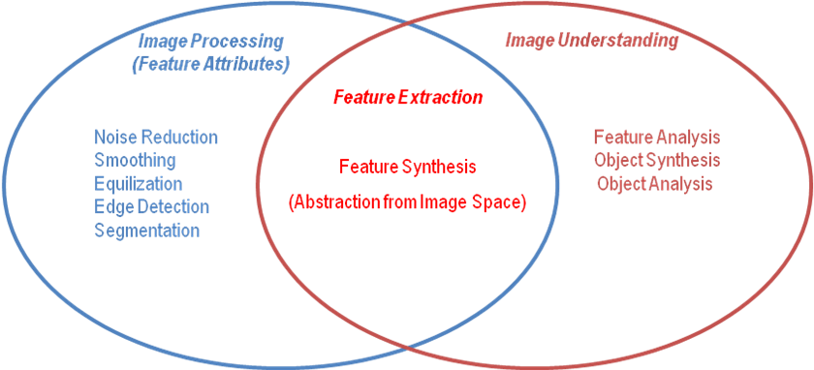
The initial phases of the image processing are usually to filter or condition the image to reduce noise or enhance significant features. There are global, localized, and point (to the image) types of operations for doing this. Histogram equalization is an example of a global operation that is often employed to bring out features in darker regions of an image.
Global Image Processing Algorithm Example: Intensity Histogram Equalization
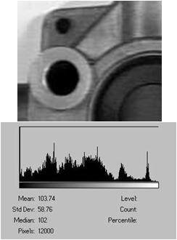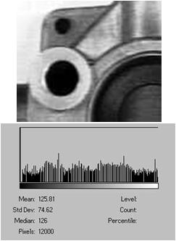
Point Image Processing Algorithm Example: Thresholding
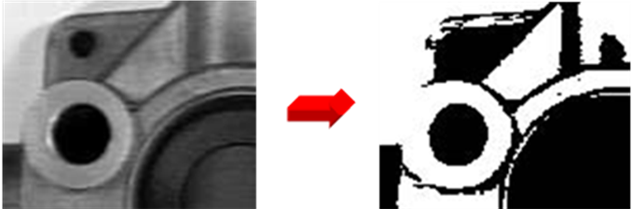
Thresholding transforms a grayscale intensity image into a binary image by assigning a value to each pixel of 1 if the intensity value at that pixel is above the selected partitioning value and 0 if the intensity value of the pixel is below the selected partitioning value. This technique is not usually robust on raw images since it is sensitive to the absolute illumination level of the image.
Localized Image Processing Algorithms
Localized algorithms are the backbone of most Machine Vision applications. They are used to condition the image (suppress noise), extract general features (extract edges), and identify targets for evaluation (define objects or shapes). There are many elements in this tool box. We’ll look at a few in more detail
- Convolution
- Smoothing
- Edge Detection
- Non-Convolution Kernals
- Noise Suppression
- Edge following
- Wildfire
- Morphology
- Image Algebra
- Structuring Elements
- Transforms
- Fourier
- Discrete Cosine
- Hough
- Wavelet
- Correlation (Template Matching)
- Binary
- Normalized Gray Scale
- Pyramid Rescaling

General Convolution Kernel Operations, 3x3 Example
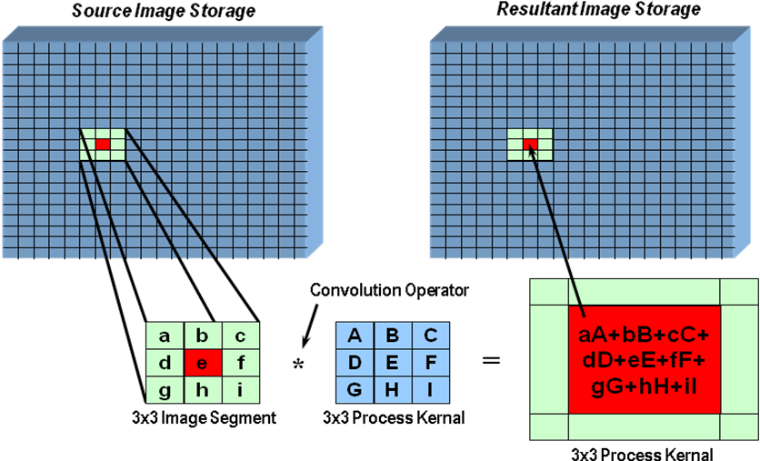
Kernel-based convolution operations are commonly used for:
- Noise Reduction or Smoothing
- Edge Enhancement or Sharpening
- Edge Detection
The mathematical processing is the same for all these divergent results, only the values of the coefficients of the kernel (or sometimes the kernel size) need to change. Smoothing is commonly done with a Gaussian kernel while “point” noise might be removed with a Rank-Order or Median Filter.
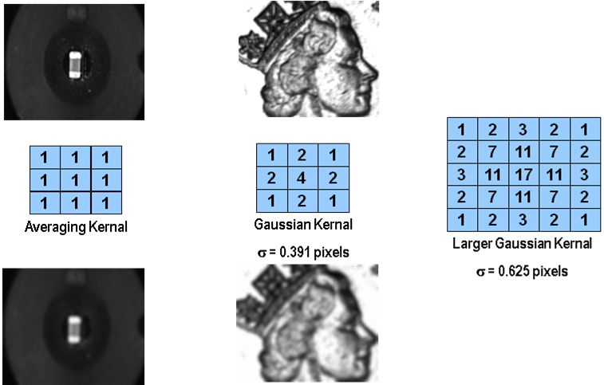
A Laplacian Convolution is be used to sharpen the edges in an image.
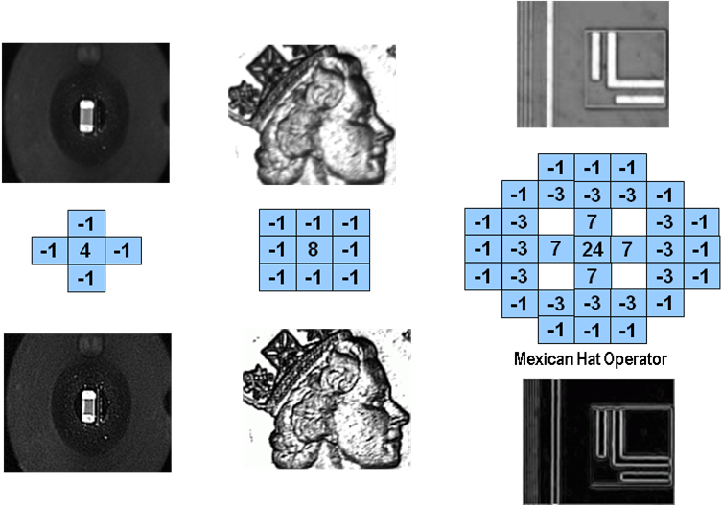
There are numerous kernel operators for extracting the edges of objects in a scene. Each has its strengths and weaknesses. The one you employ in an algorithm depends on the objectives and sensitivities of the application. In addition to the Robert’s Cross two commonly used kernels are illustrated below. A particularly powerful technique, especially for critical measurement applications is the multi-step convolution known as the “Difference of Gaussians” or DOG. Its major drawback is that it requires a longer execution time.
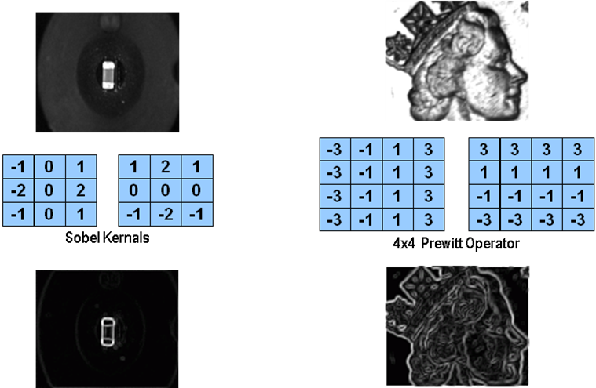

Shape-defined objects in an image are often identified using Correlation techniques. These transform the image into a correlation space that can be further processed or simply used to point out locations in the original image on which to conduct further processing. The simplest technique is Binary Template Matching as shown in the example below.
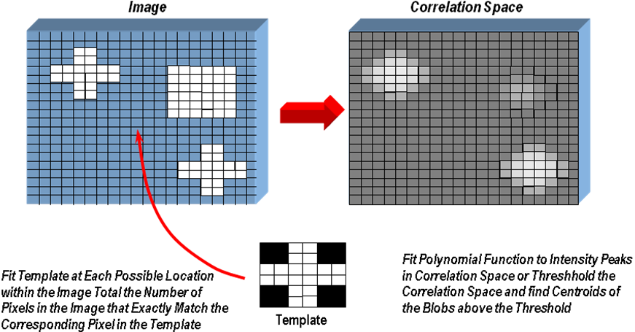
The Hough Transform is a commonly used tool for locating “shape definite” objects in an image. It can tolerate obscuring of the target but must trade off accuracy for tolerance of size variation.
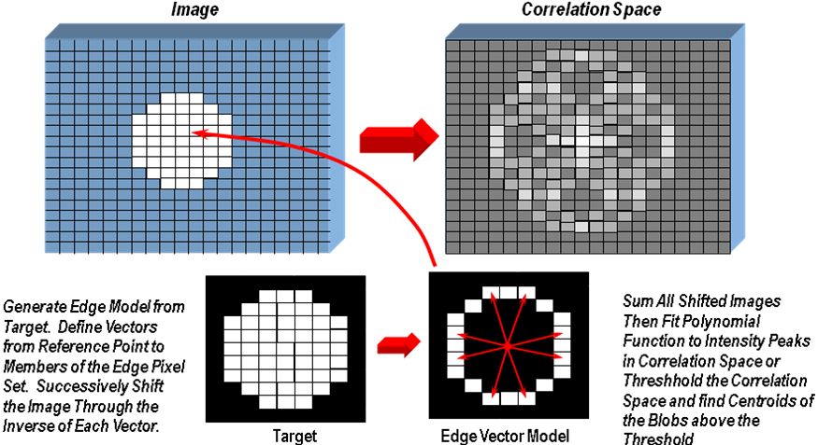
Image Morphology techniques are also used for this purpose. The algorithm set is too complex to describe here but they are especially useful for identifying flaws or missing elements of image objects or locating features in correlation space.

Once the features of significance have been extracted and the objects of interest (targets) defined, all the initial information content in the original image has been effectively reduced to a small subset of the original. At this level attributes of the targets or objects (size, location, orientation, defects) may be tabulated for final decision making. Once the data’s structure looses the rigorous spacial relationship between pixels it is no longer an image in the strict sense. At this point numerous data analysis techniques, such as, feature vectors, neural nets, fuzzy sets, response surfaces, or principal components analysis may be utilized for final analysis of the significant.
Many tool boxes such as that provided by Labview combine these techniques into function-oriented tools or appliances that insulate the user from the low level implementation while allowing parametric control of the characteristics of the processing. This does not excuse the end-user from understanding the assumptions, strengths, weaknesses, aliases, and consequences of the tools in building an application that functions correctly. This is the same sort of responsibility required when applying statistics.
Applications
You can group the broad range of machine vision applications into four classes: positioning, detection, measurement, and examination.
Positioning applications deal with the alignment or guidance of objects in the image. For instance, you may need to align chips for placement on printed circuit boards, or you might want to guide a robotic arm along a particular path. Positioning applications help you track the movement of objects in an image.
Detection applications determine the presence or absence of an object. Many times, the benefit of using machine vision for this type of application is the speed at which you can process images. For example, suppose the manufacturer of DVD-ROMs wants to ensure that each disk has a label placed at a certain location. A machine vision system can test these disks hundreds or even thousands of times faster than a human operator.
Measurement applications deal with gauging distances, angles, or other quantities through visual inspection. With robust tools like IMAQ Vision from National Instruments, you can calibrate pixels to real-world units like millimeters or miles.
Examination applications are those that identify differences among objects in one or more images. Does a cell change its shape over time in a biology experiment? What is the serial number of a unit under test? Machine vision can answer questions like these for you.
Lighting
Lighting is probably the most important part of conditioning. Because poor lighting can cause shadows and glares that degrade the performance of an image processing routine. By properly setting up an imaging environment, you can focus your development energy on the application rather than problems from the environment. The objective is to separate the feature or part you want to inspect from the surrounding background by as many gray levels as possible. Highly directional light sources, for example, increase the sensitivity of specular highlights. A few important lighting techniques include:
Back Lighting --- An object is placed between the light source and the camera to create a silhouette to simplify detecting the presence/absence of a feature or to measure a distance on a part.
Ring Light --- Provides an intense, shadow-free light in the axis of the camera. Ring lights are very often combined with polarizers, which filter glares when illuminating shiny objects.
Strobe Lights --- Turn on and off very rapidly in order to illuminate objects at very specific points in time or to reduce blur in the image.
For some applications such as food sorting, you can use near IR light sources to illuminate defects that would be otherwise invisible in the visible light spectrum. You can also use a visible cut-off filter to eliminate visible ambient lighting problems.
Edge Detection
Edge detection is an important image processing function. This function clearly determines the boundary or edge of an object and shows up as intensity discontinuities in an image. Edge detection in pattern recognition is very important; you can often recognize an object from only a crude outline. IMAQ Vision includes many different edge detection functions, such as Sobel, Sigma, Roberts, Prewitt, Gradient, and Differentiation.
Pattern Matching
Pattern matching provides information about the presence of absence, number, and location of the model within an image. For example, you can search an image containing a printed circuit board for one or more alignment marks called fiducials. You can then use the positions of the marks to align the board for chip placement from a chip-mounting device. Also, pattern matching can be used in gauging applications where key components are located. The distance or angle between these objects is gauged. If the measurement falls within a tolerance range the part is good; if not it is rejected. In many applications, searching and finding a feature is the key processing task that determines the success of the application.
Particle Analysis
Particle analysis functions are used to find dozens of parameters for the blob, such as the orientation, area, perimeter, center of mass, and coordinates of each blob. These unique parameters then can be used to identify parts in a sorting application or to ensure that the parts meet quality standards. A subset of the particle analysis function deals with morphology. These functions are useful in counting and inspection applications. With these functions, the shape of the image particles are changed so that you can count them. For example, you can use the erosion function with IMAQ to erode the perimeter of objects so that you can count two particles that are close to each other or overlapping. In addition, the morphology functions can remove small particles (an unwanted blob) caused by reflection in the image.

Acquiring and measuring an image is the foundation of all machine vision applications. In the following labs, use National Instrument's IMAQ Vision Assistant to complete the following tasks. In the last lab, use the "Script Builder" to build a LabVIEW machine vision VI for a machine vision application.

Machine Vision Tools
Lab Objective: Measure the circularity of each of the holes, the distance between the center of each of the top two holes; and the distance between each of the vertical edges.
- Open IMAQ Vision Assistant.
- Start IMAQ Vision Builder 6.0 and select “Open Image”. Load the image Holes.tif. located at C: >>> Program files >>> National Instrument >>> Vision >>> Examples
>>> Images >>> Holes.tif
- Select Circular Edge from the machine vision menu. Draw a circular region of interest around the right top hole. Notice that you can maneuver the ROI once it has been placed. You can also expand or contract either the inner or outer circle of the ROI. Experiment by moving the ROI around and changing the size of both the inner and outer circle.
- Click on the options tab and it will allow you to determine which result lines will show up. Also peruse the settings and experiment with each of the parameters.
- After you are satisfied that the center of the hole has been found, click OK.
- Follow the save routine for the top left hole. Save that step in your script giving you two Find Circular Edge steps in your script.
- Now determine the distance between the vertical edges by selecting Clamp from Machine Vision (menu).
- Draw a square region of interest encompassing the bottom half of the object. Once the ROI has been set a “rake” of lines will appear. You can adjust whether these lines go horizontal or vertical by selecting which direction. Also you can determine whether a minimum or maximum clamp will be used. Experiment with each parameter.
- The settings and options are nearly identical to those in the Find Circular Edge step. Examine these and determine the correct values for the application.
- You will notice that the distance (in pixels) is given in the lower right corner. Click OK.
- The last step in the script is to measure the distance between the centers of the two holes. Select Caliper from the machine vision menu. Select both points (1&2) so that the squares under the numbers are checked. Select distance under Select Measurement. The distance is then calculated. Press OK or Apply.
- We will now create the Labview code. Go to Tools and select Create Labview VI. Follow the wizard and your Labview block diagram and front panel will be created.
- Run the VI and the results should be exactly as they appeared in Vision Builder.
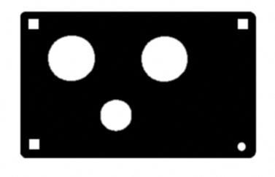
Color Pattern Matching
Lab Objective: Use Template Matching on PCB Images.
- Start IMAQ Vision Assistant and select “Open Image”. Load the images located at C: >>> Program files >>> National Instrument >>> Vision >>> Examples >>> Images >>> PcbColor.
- Click on the “select all files” box and select OK.
- Now, select Color Pattern matching from the Color menu.
- Now click on settings >>> search for rotated patterns >>> template >>> create template >>> draw a box around any one of the orange electrical component >>> click on OK (show learning template on screen) >>> Save it to Desktop and name the file template.png.
- Now, we want to match this template pattern in our image. To do this, first click on the tab labeled “Search setup”. Make sure the parameters are identical to those shown in the following image.
- Click on the “settings” tab and adjust the “search mode” to +/-180^{O} and number of matches to 4. Leave the other parameters in their default state.
- Click on the Search button. You should see a table displayed under the image that describes where each match was found and the score of the match.
- Click on OK or APPLY and close the color pattern matching step.
- Go to Tools menu to examine the efficiency of the algorithm by selecting performance meter.
- Now, test the pattern match on all of the images. Go to Tools menu and select Batch Processing. Check everything shown in the image below.
- Click the run button and you will see that the script is performed on all the images in the browser (13 total).
- Now go to Tools and generate Labview VI by selecting Create Labview VI.
- Examine the generated VI. Run the program and load in different images from the PcbColor folder. You should see that the orange component is found every time.
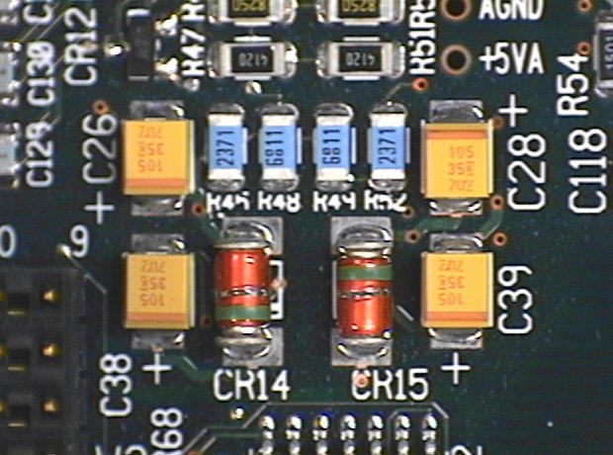
Coin Blob Analysis
Lab Objective: Use the Grayscale tools to analyze an image.

- Start IMAQ Vision Assistant and select “Open Image”. Load the image Distorted Coins.png located at C: >>> Program files >>> National Instrument >>> Vision >>> Examples >>> Images >>> Distorted Coins.png.
- Select Threshold from the Grayscale menu. Select Gray Objects. Select 60 as your min threshold and 160 as your maximum. Then Click OK.
- Now, select basic morphology from the binary menu. Select dilate object in the list and use 3 X 3 with 2 iterations. Now click Apply or OK. Then click Close.
- Now, select particle analysis from the binary menu and click on select measurements. Uncheck all buttons and check only Area (unit). Then click OK and close.
- Go to Tools and click on performance meter to examine the efficiency.
- Now go to Tools and select Create Labview VI.
- Examine the generated VI.

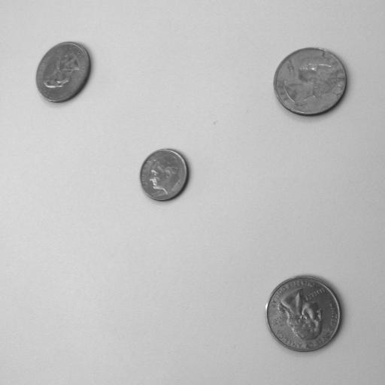

Using NI-IMAQ Script Builder

Lab Objective: Build a VI that will measure the (1) horizontal, (2) vertical distance of an object, and (3) identify the object using pattern matching. Use the “Script Builder” on the NI-IMAQ machine vision system to speed up your process.
- Use MAX to verify that the machine vision system is working. Demonstrate. (Use the grab utility).
- Open IMAQ Vision Assistant >>> Acquire Image.
- Acquire Continuous Images (Play Button).
- Draw a Region of Interest (ROI) in Image to acquire the selected area.
- Unclick Play button to continue.
- Store Image (2nd button to right of play).
- Press Close on Bottom of screen >>> Click on Process images >>> Click OK and Save script. (Make sure it's saved as an 8bit image) >> Grayscale >> Conversion
- Go to Machine Vision (menu) >>> Clamp.
- Open ROI Window across image (Until Red Lines form on both edges).
- Settings Tab (at bottom) Set at 55 – contrast, Functions Tab Set at maximum clamp – Horizontal.
- Press OK button.
- Check if script is in the left screen; says “Clamp Horizontal Max”.
- Repeat Steps 8 to 12 for Vertical Clamp (Red Lines added for vertical).
- Go to Tools >>> Performance Meter.
- Add pattern matching >>> machine vision tab.
- Select Design of Interest, create from ROI.
- Tools >>> Create VI (note: image acquire board when asked).
- Save and demonstrate (convert pixels to inches).


