Invertible Authentication Watermark for JPEG Images

Jiri Fridrich*ª, Miroslav Goljan^{b}, Rui Du^{b}
ªCenter for Intelligent Systems, ^{b}Department of Electrical Engineering,
SUNY Binghamton, Binghamton, NY 13902-6000

Abstract

In this paper, we present two new invertible watermarking methods for authentication of digital images in the JPEG format. While virtually all previous authentication watermarking schemes introduced some small amount of non-invertible distortion in the image, the new methods are invertible in the sense that, if the image is deemed authentic, the distortion due to authentication can be completely removed to obtain the original image data. The first technique is based on lossless compression of biased bit-streams derived from the quantized JPEG coefficients. The second technique modifies the quantization matrix to enable lossless embedding of one bit per DCT coefficient. Both techniques are fast and can be used for general distortion-free (invertible) data embedding. The new methods provide new information assurance tools for integrity protection of sensitive imagery, such as medical images or high-importance military images viewed under non-standard conditions when usual criteria for visibility do not apply.

1. Introduction and problem statement

In today's world, digital images are gradually replacing their classical analog counterparts. This is quite understandable because digital format is easy to edit, modify, and exploit. Digital images can be readily shared via computer networks and conveniently processed for queries in databases. Also, digital storage does not age or degrade with usage. On the other hand, thanks to powerful editing programs, it is very easy even for an amateur to maliciously modify digital media and create "perfect" forgeries. It is usually much more complicated to tamper with analog tapes and images. Tools that help us establish the authenticity and integrity of digital media are thus very essential and can prove vital whenever questions are raised about the origin of an image and its integrity.
Visual redundancy of typical images makes it possible to embed a weak imperceptible signal in the image making it capable of authenticating itself without accessing the original or other auxiliary data derived from the original. The advantage of having the authentication code embedded in the image rather than appended is obvious. Lossless format conversion leads to a different representation of the image data but does not change the visual appearance of the image and its authenticity status. Also, if the authentication information is lumped and localized in the image, one can localize the modifications as well as verify the content integrity of image fragments after cropping. Another advantage of fragile watermarks is that authentication based on invisible watermarking is less obvious.
One possible drawback of authentication based on watermarking is the fact that the authenticated image will inevitably be distorted by some small amount of noise due to the authentication itself. In virtually all previously proposed authentication watermarking schemes [3−5], this distortion cannot be completely removed even when the image is deemed authentic. Although the distortion is often quite small, it may be unacceptable for medical imagery (for legal reasons) or images with a high strategic importance in certain military applications. In the case of JPEG files, the extent of the modifications must be obviously higher than for uncompressed image formats, which makes the issue of distortion more pressing.
The general paradigm of authentication based on watermarking assumes that the image can be divided into two disjoint sets: The set that determines the Message Authentication Code or MAC (hash or some other derived image features) and the set that will hold the MAC. It is important that these two sets do not interact, so that the act of embedding the MAC does not change the MAC itself. These two sets may consist of the seven most significant bits and the set of all least significant bits. In algorithms that work directly with JPEG streams, certain subset of coefficients or blocks [5] is assigned to one set while a different set of coefficients (or blocks) holds the authentication bits. This paradigm, however, always seems to introduce some additional weakness into the algorithm and makes it vulnerable to attacks. This seems to be especially true when pairs of original and authenticated images become available or when an attacker can submit his image for authentication or for integrity verification [3]. For a more detailed discussion and classification of attacks on authentication watermarks the reader is referred to the paper by Fridrich [3].
The concept of invertible (or lossless) authentication and data embedding enables us to design watermarks that do not follow the above-mentioned paradigm. The MAC will be calculated from the whole image and embedded in a lossless (invertible) manner in the image. After a positive integrity check, the extracted MAC can be used to completely remove the authentication watermark from the watermarked image. Even though the watermark is completely invertible, we still pay close attention to the distortion introduced to the image and try to keep it as small as possible.
In this paper, we describe two watermarking techniques for JPEG files that embed a MAC in quantized DCT coefficients in an invertible way so that anyone who possesses the authentication key can revert to the exact copy of the original image before authentication occurred. The first technique described in the next section is based on lossless compression of biased bit-streams derived from the quantized coefficients. In Section 3, we introduce another very simple technique in which one entry of the quantization table is modified to obtain a completely biased sequence of coefficients that can be readily used for lossless data embedding and authentication. The paper is concluded in Section 4. This work is a continuation and further expansion of our previous papers on invertible watermarking and distortion-free data embedding [1, 2].

2. Invertible authentication of JPEG files (Method 1)

Following the methodology for lossless authentication first described in [1], let us assume that we have an object X represented in a discrete form using bits. For example, X could be a JPEG file, a complex multimedia object, an audio file, a digitized hologram, a representation of a 3D structure, or any other digital object that needs to be authenticated. Let us further assume that it is possible to identify a subset E ⊂ X that has a structure and that can be randomized without changing the essential properties of X or its semantic meaning. For authentication, the subset E needs to have enough structure to allow lossless compression by at least 128 bits (the hash of X). One can then authenticate X in an invertible manner by replacing the subset E with an encrypted version of its compressed form concatenated with the hash H(X).
We note that if the set E is easily compressible, we do not need to work with the whole set E but only with a smaller portion of it that would give us enough space for the hash after lossless compression. We use this general authentication principle to develop invertible authentication of JPEG files.
Although in this paper, we explain the techniques on grayscale images, the technology can be extended to color images in a straightforward manner. JPEG compression starts with dividing the image into disjoint blocks of 8×8 pixels. For each block, the discrete cosine transform (DCT) is calculated, producing 64 DCT coefficients. Let us denote the (i,j)-th DCT coefficient of the k-th block as d_{k}(i,j), 0 ≤ i, j ≤ 64, k = 1, …, B, where B is the total number of blocks in the image. In each block, all 64 coefficients are further quantized to integers D_{k}(i,j) with a JPEG quantization matrix Q

$D_{k}(i,j)={\text{integer}}_{\text{round}}\left(\frac{d_{k}(i,j)}{Q(i,j)}\right)$ .

The quantized coefficients are arranged in a zig-zag manner and compressed using the Huffman coder. The resulting compressed stream together with a header forms the final JPEG file.
The largest DCT coefficients occur for the lowest frequencies (small i and j). Due to properties of typical images and due to quantization, the quantized DCT coefficients corresponding to higher frequencies have a large number of zeros or small integers, such as 1's or −1's. For example, for the classical grayscale test image 'Lenna' with 256×256 pixels, the DCT coefficient (5,5) is zero in 94.14% of all blocks. In 2.66% cases it is a 1, and in 2.81% cases it is equal to −1, with less than 1% of 2's and −2's. Thus, the sequence D_{k}(5,5) forms a subset E that is easily compressible with a simple Huffman or arithmetic coder. Furthermore, if we embed message bits (the hash) into the LSBs of the coefficients D_{k}(5,5), we only need to compress the original LSBs of the sequence D_{k}(5,5) instead of the whole sequence. We can further improve the efficiency of the algorithm if we define the LSB of negative integers D_{k} < 0 as LSB(D_{k}) = 1 − (|D_{k}| mod 2). Thus, LSB(−1)=LSB(−3)=0, and LSB(−2)=LSB(−4)=1, etc. Because DCT coefficients D_{k} have a symmetrical distribution with zero mean, this simple measure will increase the bias between zeros and ones in the LSB bit-stream of original DCT coefficients.

DCT coefficients D_{k}(i,j) corresponding to higher-frequencies will produce a set E with a larger bias between zeros and ones, but because the quantization factor Q(i,j) is also higher for such coefficients, the distortion in each modified block will also be higher. To obtain the best results, one should use different DCT coefficients for different JPEG quality factors to minimize the overall distortion and avoid introducing easily detectable artifacts.
Below, we give a pseudo-code for lossless authentication of grayscale JPEG files.

Algorithm for invertible authentication of JPEG files

- Based on the JPEG quality factor, determine the set of L authentication pairs (i₁,j₁), (i₂,j₂), …, (i_{L},j_{L}), 0 ≤ i_{l}, j_{l} ≤ 64, in middle frequencies.
- Read the JPEG file and use Huffman decompressor to obtain the values of quantized DCT coefficients, D_{k}(i,j), 0 ≤ i, j ≤ 64, k = 1, …, B, where B is the total number of blocks in the image.
- Calculate the hash H of the Huffman decompressed stream D_{k}(i,j).
- Seed a PRNG with a secret key and follow a random non-intersecting walk through the set E={D₁(i₁,j₁), …, D_{B}(i₁,j₁), D₁(i₂,j₂), …, D_{B}(i₂,j₂), …, D₁(i_{L},j_{L}), …, D_{B}(i_{L},j_{L})}. There are L×B elements in the set E.
- While following the random walk, run the adaptive context-free lossless arithmetic compression algorithm for the least significant bits of the coefficients from E. While compressing, check for the difference between the length of the compressed bit-stream C and the number of processed coefficients. Once there is enough space to insert the hash H, stop running the compression algorithm. Denote the set of visited coefficients as E₁, E₁ ⊆ E.
- Concatenate the compressed bit-stream C and the hash H and insert the resulting bit-stream into the least significant bits of the coefficients from E₁. Huffman compress all DCT coefficients D_{k}(i,j) including the modified ones and store the authenticated image as a JPEG file on a disk.

Integrity verification:

- Based on the JPEG quality factor, determine the set of L authentication pairs (i₁,j₁), (i₂,j₂), …, (i_{L},j_{L}), 0 ≤ i_{l}, j_{l} ≤ 64.
- Read the JPEG file and use Huffman decompressor to obtain the values of quantized DCT coefficients, D_{k}(i,j), 0 ≤ i, j ≤ 64, k = 1, …, B.
- Seed a PRNG with a secret key and follow a random non-intersecting walk through the set E={D₁(i₁,j₁), …, D_{B}(i₁,j₁), D₁(i₂,j₂), …, D_{B}(i₂,j₂), …, D₁(i_{L},j_{L}), …, D_{B}(i_{L},j_{L})}.
- While following the random walk, run the context-free lossless arithmetic decompression algorithm for the least significant bits of the coefficients visited during the random walk. Once the length of the decompressed bit-stream reaches B+|H| (the number of 8×8 blocks in the image plus the hash length), stop the procedure.
- Separate the decompressed bit-stream into the LSBs of visited DCT coefficients and the extracted candidate for hash H'. Replace the LSBs of all visited coefficients with the decompressed bit-stream and calculate the hash H of the resulting stream of all quantized DCT coefficients D_{k}(i,j), 0 ≤ i, j ≤ 64, k = 1, …, B.
- Compare H' with H. If they agree, the JPEG file is authentic and the original JPEG image is obtained. If H≠H', the image is deemed non-authentic.

The selection of the L authentication coefficients can be adjusted according to the quality factor to minimize the distortion and other artifacts. For example, using L=3 coefficients (5,5), (4,6), and (6,3) in a random fashion will contribute to the overall security of the scheme because the statistical artifacts due to lossless authentication will be more difficult to detect.
For color JPEG images, we have found that using the chrominance instead of the luminance always introduced much less visible distortion into the image.
Table 1 below shows the distortion measured using the PSNR. For simplicity, in our experiments we used one fixed DCT coefficient (6,6) and three color test images. The JPEG images were obtained by saving raw bitmaps as JPEGs with four different quality factors in PaintShop Pro 4.12. As expected, the distortion increases with the compression ratio.

3. Invertible authentication of JPEG files (Method 2)

The idea for the second method is quite simple. If, for a given DCT coefficient (i,j) the quantization factor Q(i,j) is even, we could divide it by two and multiply all coefficients D_{k}(i,j) by two without changing the visual appearance of the image at all. Because now all D_{k}(i,j) are even, we can embed any binary message into the LSBs of D_{k}(i,j) and this LSB embedding will be trivially invertible.

If Q(i,j) is odd, we replace it with floor(Q(i,j)/2) and multiply all D_{k}(i,j) by two. In this case, we need to include a flag to the hash telling us that Q(i,j) was originally odd in order to be able to reconstruct the original JPEG stream during verification. Because this method uses a non-standard quantization table, the table must be included in the header of the authenticated image. Because the table entry Q(i,j) will not be compatible with the rest of the table, this authentication method is steganographically obvious.

Test image | Distortion (dB)
Test image | JPEG 90% | JPEG 85% | JPEG 75% | JPEG 50%
P1 (512×330) | 55.0 (42.0) | 52.0 (38.8) | 48.0 (34.6) | 43.0 (28.8)
P2 (256×256) | 50.5 (38.6) | 47.8 (35.3) | 44.0 (30.0) | 37.6 (25.2)
P3 (878×586) | 59.7 (46.4) | 56.6 (43.3) | 53.6 (39.2) | 47.2 (33.4)
Table 1 Distortion for lossless JPEG authentication and for embedding 4000 bits in an invertible manner (numbers in parenthesis) for three test images P1, P2, P3, and different JPEG quality factors.

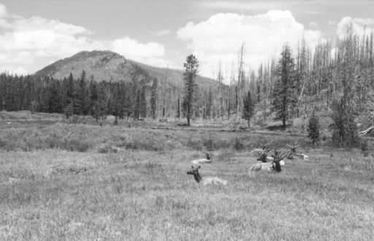 | 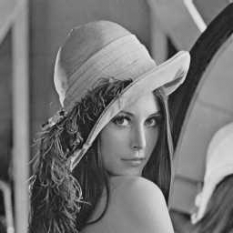 | 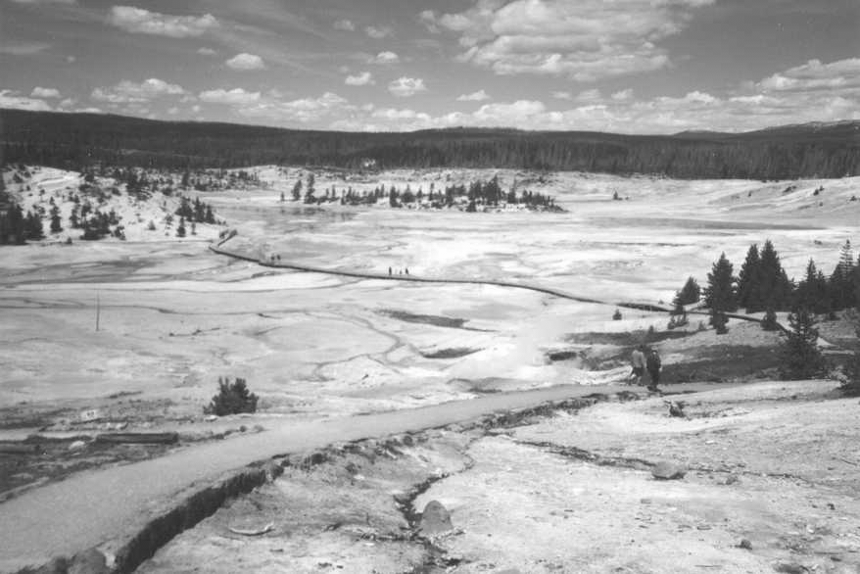
Figure 1 Three color test images P1, P2, and P3.

 |  | Method 2 D_{k}(i,j)→ D_{k}(i,j)/2 |  |  | Method 2 D_{k}(i,j)→ 1
Image | QF | (6,6) | (5,4) | (4,2) | (6,6) | (5,4) | (4,2)
P1  512×330 | 50 | 49.3 (34.7) | 46.5 (32.3) | 49.2 (33.2) | 66.6 (54.4) | 66.2 (54.6) | 66.6 (54.2)
P1  512×330 | 75 | 54.6 (40.4) | 52.0 (38.0) | 52.9 (39.1) | 66.9 (55.0) | 66.5 (55.2) | 67.0 (54.8)
P1  512×330 | 85 | 58.0 (44.4) | 55.6 (42.1) | 57.0 (43.1) | 66.5 (55.0) | 66.0 (55.0) | 66.6 (54.8)
P1  512×330 | 90 | 60.4 (47.1) | 58.6 (45.1) | 58.7 (46.3) | 66.9 (55.1) | 66.7 (55.1) | 67.0 (54.7)
P2  256×256 | 50 | 43.7 (31.1) | 40.8 (28.2) | 43.2 (27.1) | 62.0 (53.5) | 61.8 (53.1) | 62.0 (52.7)
P2  256×256 | 75 | 50.8 (37.1) | 48.1 (34.3) | 49.0 (32.9) | 62.7 (53.5) | 62.2 (53.0) | 62.5 (52.5)
P2  256×256 | 85 | 54.1 (41.2) | 51.5 (38.5) | 53.1 (37.2) | 62.3 (53.5) | 61.8 (53.0) | 62.5 (52.6)
P2  256×256 | 90 | 56.0 (44.3) | 54.0 (41.8) | 54.7 (40.7) | 62.5 (53.5) | 62.3 (53.1) | 62.2 (52.5)
P3  878×586 | 50 | 53.6 (39.4) | 50.7 (36.4) | 53.3 (38.4) | 70.8 (56.8) | 70.3 (56.4) | 70.6 (56.7)
P3  878×586 | 75 | 59.2 (44.8) | 56.6 (42.0) | 57.6 (44.2) | 71.4 (57.8) | 71.4 (57.4) | 71.8 (57.7)
P3  878×586 | 85 | 62.7 (48.4) | 60.3 (45.8) | 61.7 (47.5) | 71.4 (58.0) | 70.6 (57.6) | 71.2 (57.9)
P3  878×586 | 90 | 64.9 (50.5) | 63.0 (48.5) | 61.7 (50.4) | 71.7 (58.1) | 71.5 (57.7) | 71.6 (57.9)
Table 2 PSNR for invertible authentication and for a 4000-bit message (in parenthesis) for three test images, four quality factors, and three different DCT coefficients.

One can imagine several other possible implementations of the above idea. For example, we could replace Q(i,j) with a 1 instead of its half and multiply each D_{k}(i,j) with Q(i,j). This version of the method will introduce very small distortion because the DCT coefficients used for embedding have a quantization factor equal to 1. On the other hand, the modified stream of quantized coefficients will be less compressible using the Huffman code thus worsening the overall compression ratio.
Both methods can be used for general data embedding. In Table 2, we give the PSNR for three different images (P1, P2, and P3), four different quality factors (25, 50, 75, and 98), and three choices for the coefficient D_{k}(i,j) − (6,6), (5,4), and (4,2), and three color images. The numbers in parenthesis correspond to a 4000 bit message. Table 3 shows the file sizes before and after embedding for the coefficient (6,6).

4. Conclusions and summary

In this paper, we present two new methods for invertible (or lossless) authentication watermarks for JPEG files. Both methods can be conveniently added to JPEG compressors and decompressors. The distortion due to watermarking is very small and can be completely removed from the watermarked image if it is deemed authentic. In the first method, the original LSBs of selected middle frequency coefficients are losslessly compressed and inserted with the hash of the whole image into the LSBs of the same coefficients. In the second method, one selected quantization coefficient from the quantization table is either changed to half its value (or to 1), and all corresponding coefficients in all blocks of the image are multiplied by two (or by the coefficient itself) to keep the image appearance unchanged. Simple LSB embedding in those modified coefficients is then used to invertibly embed the hash or some other message. The authentication methods work in the quantized coefficient space. The second method is more obvious than the first one, but the distortion due to message embedding is smaller and the capacity higher. Numerical experiments on images indicate that the overall PSNR of the watermarked images is very high (up to 70dB or more for the second method). Our future effort will be focused on extending the methods to the MPEG-2 format.

Image | QF | Original Size | Method 1 | Method 2 | Method 3
P1 | 50 | 19,413 | 19,617 | 19,608 | 19,627
P1 | 75 | 30,451 | 30,711 | 30,713 | 30,674
P1 | 85 | 41,865 | 42,138 | 42,119 | 42,065
P1 | 90 | 53,292 | 53,574 | 53,551 | 53,478
P2 | 50 | 7,969 | 8,181 | 8,169 | 8,172
P2 | 75 | 11,782 | 11,997 | 11,990 | 11,948
P2 | 85 | 15,818 | 16,025 | 16,019 | 15,986
P2 | 90 | 19,839 | 20,060 | 20,045 | 20,008
P3 | 50 | 52,864 | 53,452 | 53,126 | 53,089
P3 | 75 | 81,281 | 81,606 | 81,597 | 81,513
P3 | 85 | 110,441 | 110,721 | 110,748 | 110,692
P3 | 90 | 140,098 | 140,389 | 140,392 | 140,332
Table 3 File sizes in bytes before and after embedding the image hash (128 bits).
All experiments were done with the DCT coefficient (6,6).

5. Acknowlegments

The work on this paper was supported by Air Force Research Laboratory, Air Force Material Command, USAF, under the grant number F30602-00-1-0521. The U.S. Government is authorized to reproduce and distribute reprints for Governmental purposes notwithstanding any copyright notation there on. The views and conclusions contained herein are those of the authors and should not be interpreted as necessarily representing the official policies, either expressed or implied, of Air Force Research Laboratory, or the U. S. Government.

6. References

- J. Fridrich, M. Goljan, and R Du, “Invertible Authentication”, Proc. SPIE, Security and Watermarking of Multimedia Contents, San Jose, California, January 23−26, 2001.

- J. Fridrich, M. Goljan, and R. Du, “Distortion-free Data Embedding”, submitted to the 4th Information Hiding Workshop, Pittsburgh, Pennsylvania, April, 2001.
- J. Fridrich, “Security of Fragile Authentication Watermarks with Localization”, submitted to the 4th Information Hiding Workshop, Pittsburgh, Pennsylvania, April, 2001.
- C.-Y. Lin and S.-F. Chang, "Semi-Fragile Watermarking for Authenticating JPEG Visual Content", Proc. SPIE, Security and Watermarking of Multimedia Contents, San Jose, California, January 2000, pp. 140−151.
- L. M. Marvel, G. W. Hartwig, and C. Boncelet, Jr., "Compression-Compatible Fragile and Semi-Fragile Tamper Detection", Proc. SPIE, Security and Watermarking of Multimedia Contents, San Jose, California, January 2000, pp. 140−151.

* Correspondence: Email: fridrich@binghamton.edu; WWW: http://www.ssie.binghamton.edu/fridrich; Telephone: 607 777 2577; Fax: 607 777 2577

